
P
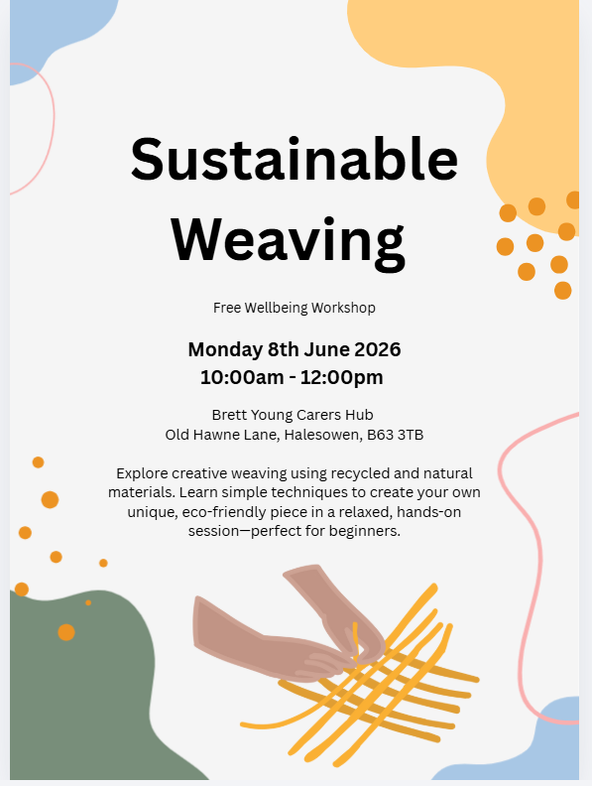Please contact us on 01384 818723 or dudleycarershub@dudley.gov.uk to book a place on this workshop.

